**Title of PBL:**

**Water Conservation and Ground Water Recharge for ITM University**

The artificial recharge to ground water aims at augmentation of ground water reservoir by modifying the natural movement of surface water utilizing suitable civil construction techniques. Artificial recharge techniques normally address to following issues

To enhance the sustainable yield in areas where over-development has depleted the aquifer.

Conservation and storage of excess surface water for future requirements, since these requirements often changes within a season or a period.

To improve the quality of existing ground water through dilution.

To remove bacteriological and other impurities from sewage and waste water so that water is suitable for re-use.

The basic purpose of artificial recharge of ground water is to restore supplies from aquifers depleted due to excessive ground water development.

**Concept of Augmenting Ground Water Reservoir**

Ground Water or Sub-Surface Reservoirs: The sub-surface reservoirs are very attractive and technically feasible alternatives for storing surplus monsoon run off. The sub-surface reservoirs can store substantial quantity of water. The sub-surface geological formations may be considered as "warehouse" for storing water that come from sources located on the land surface. Besides suitable lithological condition, other considerations for creating sub-surface storages are favourable geological structures and physiographic units, whose dimensions and shape will allow retention of substantial volume of water in porous and permeable formations.

The sub-surface reservoirs, located in suitable hydrogeological situations, are environment friendly and economically viable proposition. The sub-surface storages have advantages of being free from the adverse effects like inundation of large surface area, loss of cultivable land, displacement of local population, substantial evaporation losses and sensitivity to earthquakes. No gigantic structures are needed to store water. The underground storage of water would also have beneficial influence on the existing ground water regime. The deeper water levels in many parts of the country, either of natural occurrence or due to excessive ground water development, may be substantially raised, resulting in reduction in lifting costs and energy saving. The quality of natural ground 6 water would substantially improve in brackish and saline areas. The conduit function of aquifers thereby reducing the cost intensive surface water conveyance system. The effluence resulting from such sub-surface storage at various surface intersection points in the form of spring line, or stream emergence, would enhance the river flows and improve the presently degraded ecosystem of riverine tracts, particularly in the outfall areas. The structures required for recharging ground water reservoirs are of small dimensions and cost effective, such as check dams, percolation tanks, surface spreading basins, pits, subsurface dykes etc. **Basic Requirement for Artificial Recharge Projects**: The basic requirements for recharging the ground water reservoir are: a) Availability of non-committed surplus monsoon run off in space and time. b) Identification of suitable hydrogeological environment and sites for creating subsurface reservoir through cost effective artificial recharge techniques.

**Source Water Availability**: The availability of source water, one of the prime requisites for ground water recharge, is basically assessed in terms of non-committed surplus monsoon run off, which as per present water resource development scenario is going unutilized. This component can be assessed by analyzing the monsoon rainfall pattern, its frequency, number of rainy days, maximum rainfall in a day and its variation in space and time. The variations in rainfall pattern in space and time, and its relevance in relation to the scope for artificial recharge to sub-surface reservoirs can be considered for assessing the surplus surface water availability.

**Hydrogeological Aspects**: Detailed knowledge of geological and hydrological features of the area is necessary for adequately selecting the site and the type of recharge structure. In particular, the features, parameters and data to be considered are: geological boundaries; hydraulic boundaries; inflow and outflow of waters; storage capacity; porosity; hydraulic conductivity; transmissivity; natural discharge of springs; water resources available for recharge; natural recharge; water balance; lithology; depth of the aquifer; and tectonic boundaries. The aquifers best suited for artificial recharge are those aquifers which absorb large quantities of water and do not release them too quickly. Theoretically this will imply that the vertical hydraulic conductivity is high, while the horizontal hydraulic conductivity is moderate. These two conditions are not often encountered in nature.

The evaluation of the storage potential of sub-surface reservoirs is invariably based on the knowledge of dimensional data of reservoir rock, which includes their thickness and lateral extent. The availability of sub-surface storage space and its replenishment capacity further govern the extent of recharge. The hydrogeological situation in each area needs to be appraised with a view to assess the recharge capabilities of the underlying hydrogeological formations. The unsaturated thickness of rock formations, occurring beyond three meters below ground level should be considered to assess the requirement of water to build up the sub-surface storage by saturating the entire thickness of the vadose up to 3 m. below ground level.

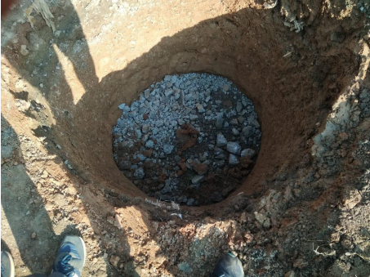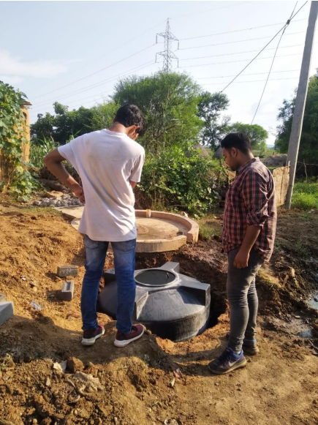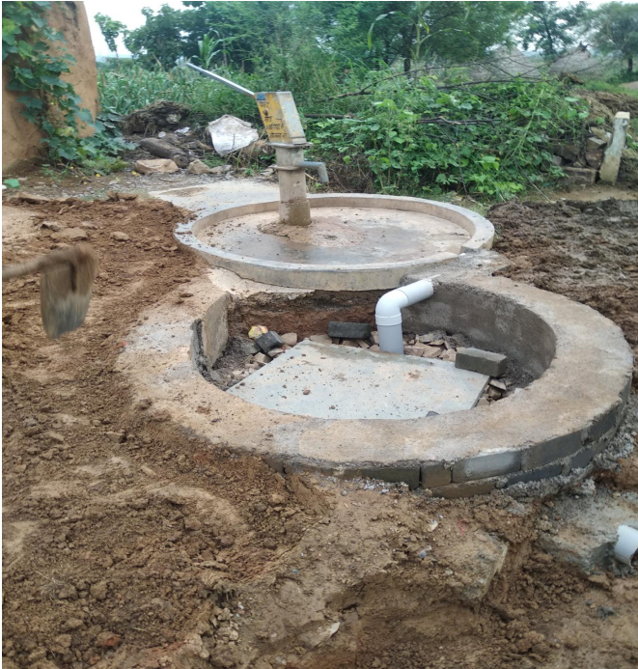The upper 3 m of the unsaturated zone is not considered for recharging, since it may cause adverse environmental impact e.g. water logging, soil salinity, etc. The postmonsoon depth to water level represents a situation of minimum thickness of vadose zone available for recharge which can be considered vis-a-vis surplus monsoon run off in the area.

The artificial recharge techniques inter relate land integrate the source water to ground water reservoir. Two effects are generated by artificial recharge in ground water reservoir namely - (a) Rise in water level and (b) increment in the total volume of the ground water reservoir.

